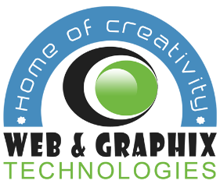 | Web and Graphix Technologies  Website: www.webandgraphix.co.ke  Email: info@ webandgraphix.co.ke  Tel: 0729250277 / 0207864809

BRAND DEVELOPMENT QUESTIONNAIRE

There are certain questions we like to ask a client prior to beginning the branding process, to ensure good, clear communication. It may seem like a long list but it is helps us to know what you, our client, needs and expects from your finished branding. It also helps to clarify your own vision for your business branding. Please take a little while to fill in this questionnaire:

YOUR BUSINESS
- What is the name of your business?

- Describe in one sentence your business/service

- Who are your main competitors and how do you differ from them?

- What do you like or dislike about your competitor’s branding?

- Who are your potential clients?

YOUR LOGO
- Do you have a specific idea in mind for your logo?

- Do you want to use existing brand colours or a particular range of
colours?

- Are there any colors that you do not want to use?

- Do you have a particular font you would like to use – or ones you definitely do not want to use?

- What logos do you like and why?

- Does your logo have a tag line?

THE PRACTICAL BITS!
- When do you want your logo to be web/print-ready?

- What is your Budget?

- Would you like any additional design services alongside your new logo? (e.g. business cards, letterheads & other stationery, social media icons/banners, advertising material etc.)

- Any other comments?

